Modelling an Anti-lock Braking System

ABS or an Anti-Lock Braking System is a piece of safety equipment that prevents the wheels of a vehicle from locking up under emergency, panic, or harsh braking conditions.

The wheel rotates with an initial angular speed that corresponds to the vehicle speed before the brakes are applied. We used separate integrators to compute wheel angular speed and vehicle speed. We use two speeds to calculate slip, which is determined by Equation 1. Note that we introduce vehicle speed expressed as an angular velocity (see below).

$$\omega_v = \frac{V}{R} \mbox{ (equals the wheel angular speed if there is no slip)}$$

**Equation 1**

$$ \omega_v = \frac{V_v}{R_r}$$

$$slip=1-\frac{\omega_w}{\omega_v}$$

$$\omega_v = \mbox{ vehicle speed divided by wheel radius}$$

$$ V_v = \mbox{ vehicle linear velocity}$$

$$ R_r = \mbox{ wheel radius}$$

$$ \omega_w = \mbox{ wheel angular velocity}$$

From these expressions, we see that slip is zero when wheel speed and vehicle speed are equal, and slip equals one when the wheel is locked. A desirable slip value is 0.2, which means that the number of wheel revolutions equals 0.8 times the number of revolutions under non-braking conditions with the same vehicle velocity. This maximizes the adhesion between the tire and road and minimizes the stopping distance with the available friction.

Image of the model

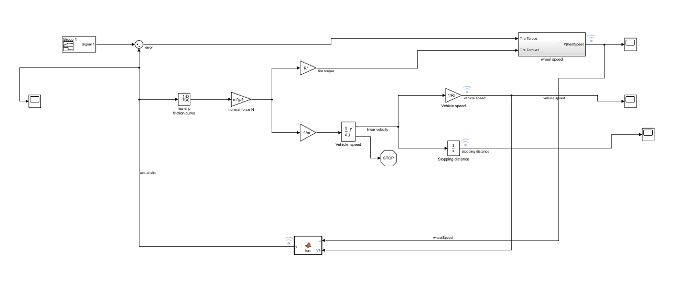

This is the model for an Anti-lock braking system.

* Reference subsystem.

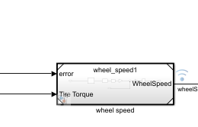

Figure 1 reference model

Here the input is Tire Torque and error. The output is Wheel speed.

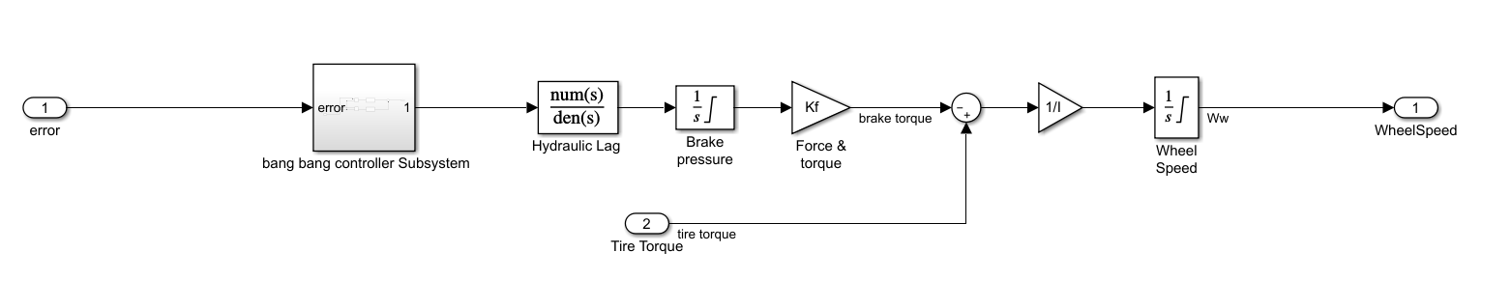Figure 2 Inside Reference Model

To control the rate of change of brake pressure, the model subtracts actual slip from the desired slip and feeds this signal into a bang-bang control (+1 or -1, depending on the sign of the error). This on/off rate passes through a first-order lag that represents the delay associated with the hydraulic lines of the brake system. The model then integrates the filtered rate to yield the actual brake pressure. The resulting signal, multiplied by the piston area and radius with respect to the wheel (Kf), is the brake torque applied to the wheel.

The model multiplies the frictional force on the wheel by the wheel radius (Rr) to give the accelerating torque of the road surface on the wheel. The brake torque is subtracted to give the net torque on the wheel. Dividing the net torque by the wheel rotational inertia, I, yields the wheel acceleration, which is then integrated to provide wheel velocity. In order to keep the wheel speed and vehicle speed positive, limited integrators are used in this model.

* Subsystem

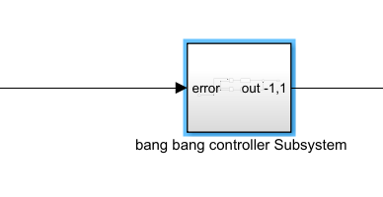

Figure 3 Bang Bang controller subsystem

Here, when the input is greater than 0, output will be 1. When input is less than 0, Output will be -1.

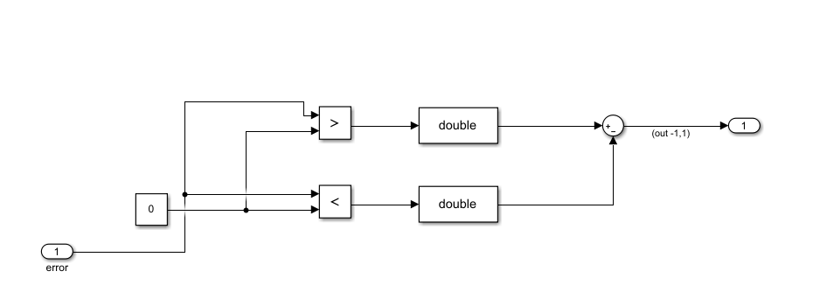

Figure 4: inside Bang-Bang controller

Here greater than, less than block is used along with data type converter. In the converter, integer rounding mode is changed from floor to ZERO. Also, output data type is changed to DOUBLE. A constant block with value zero is used to as input to the comparison blocks.

* Look-up table

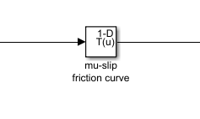

Figure 5: look-up table

The friction coefficient between the tire and the road surface, mu, is an empirical function of slip, known as the mu-slip curve. We created mu-slip curves by passing MATLAB variables into the block diagram using a Simulink lookup table. The model multiplies the friction coefficient, mu, by the weight on the wheel, W, to yield the frictional force, Ff, acting on the circumference of the tire. Ff is divided by the vehicle mass to produce the vehicle deceleration, which the model integrates to obtain vehicle velocity.

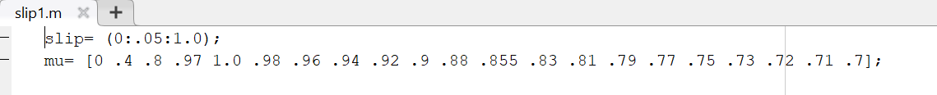

Figure :Script file for look-up table

* Matlab Function block

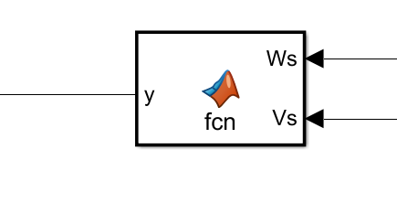

Figure 7: Function Block

Here, the Functional block calculates the relative slip using an equation which is given in the corresponding, matlab function script.

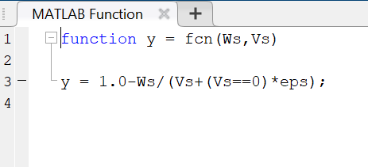

Figure 8: MATLAB script file for function Block

* Solver selection Strategy

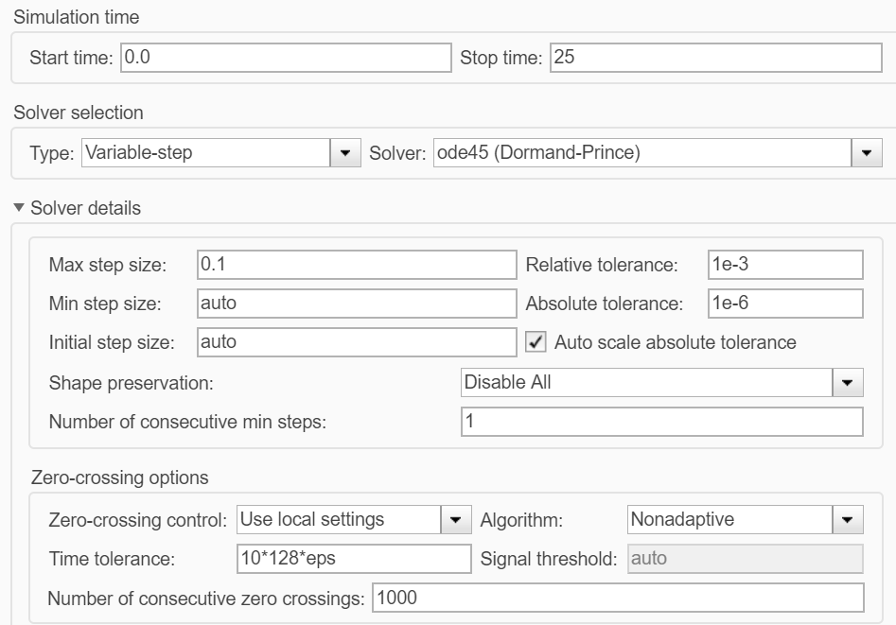

Figure 9: solver parameters

Here we have Non stiff problem type so we use Ode 45. Also, we get medium accuracy.

* Callbacks

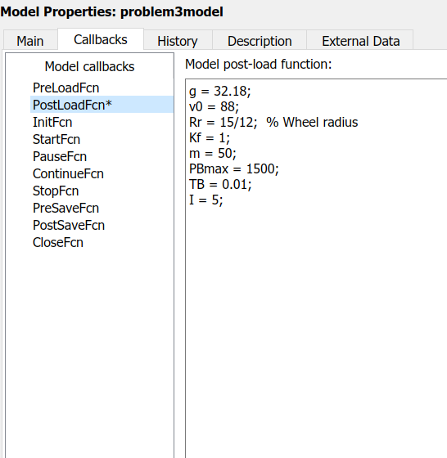

Figure 10: callbacks

* Signal builder

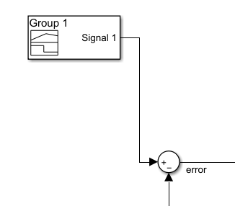

Figure : singal builder